**1. Serverless Architecture & Workflow**

1. **Definition**
   * **Serverless** (FaaS) means you write individual “functions,” and a cloud provider automatically:
     + Provisions compute behind the scenes
     + Autos-scales to zero (no functions running → no cost)
     + Bills you per-invocation + compute-time
   * You never manage servers or VMs directly.
2. **Key Components**
   * **Event Source**: e.g. API Gateway, S3 event, message queue
   * **Function**: your code packaged as a handler (NodeJS, Java, Python, or container)
   * **Compute Fabric**: opaque to you—spins up containers or VMs on demand
   * **Trigger & Execution**: event → cloud event router → function container → runs your code → returns result
   * **Monitoring & Logging**: e.g. CloudWatch captures logs/metrics automatically
3. **Typical Workflow**

Developer writes function handler → Packages code (+deps) as ZIP or container image → Deploys via CLI/​console/​IaC (SAM, Serverless Framework) → Cloud provider registers event source (API, queue, cron…) → Event occurs → provider fetches code → runs in ephemeral container → returns response → Logs emitted to monitoring service → container destroyed (or frozen until next call)

**2. “Hello World” Serverless in Java**

**Commands:**

1. sudo apt update && sudo apt install -y unzip curl git
2. sudo apt install -y openjdk-11-jdk maven
3. curl "https://awscli.amazonaws.com/awscli-exe-linux-x86_64.zip" -o "awscliv2.zip"
4. unzip awscliv2.zip
5. sudo ./aws/install
6. curl -Lo sam.zip <https://github.com/aws/aws-sam-cli/releases/latest/download/aws-sam-cli-linux-x86_64.zip>
7. unzip sam.zip -d sam-installation
8. sudo ./sam-installation/install
9. java -version
10. mvn -v
11. aws --version
12. sam --version

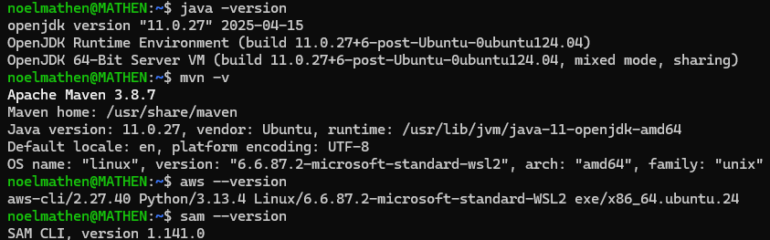

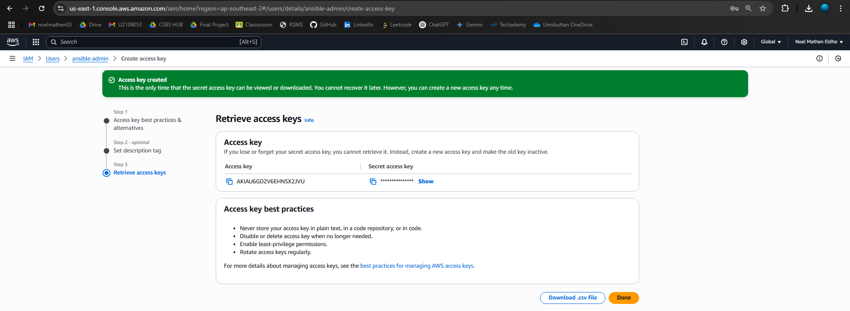

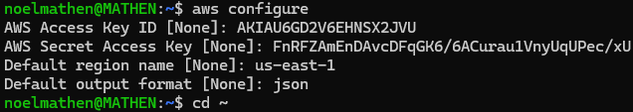

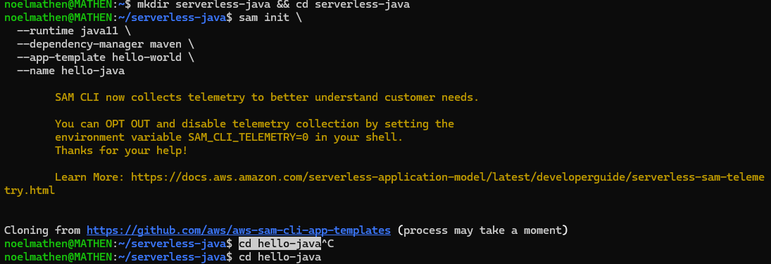

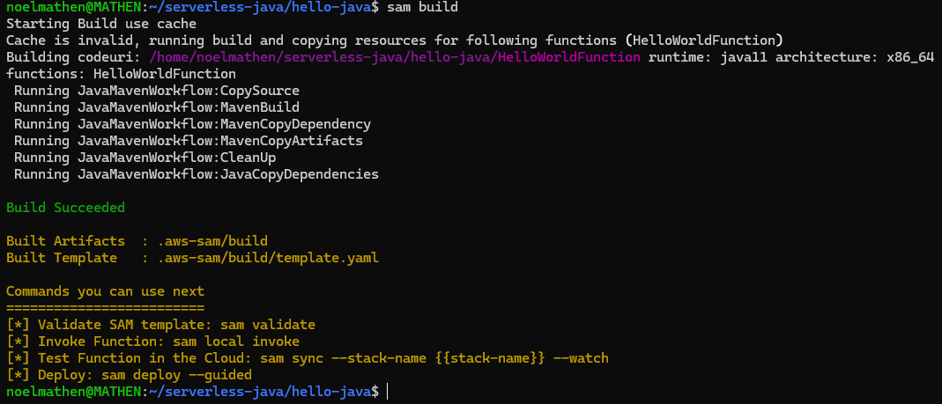

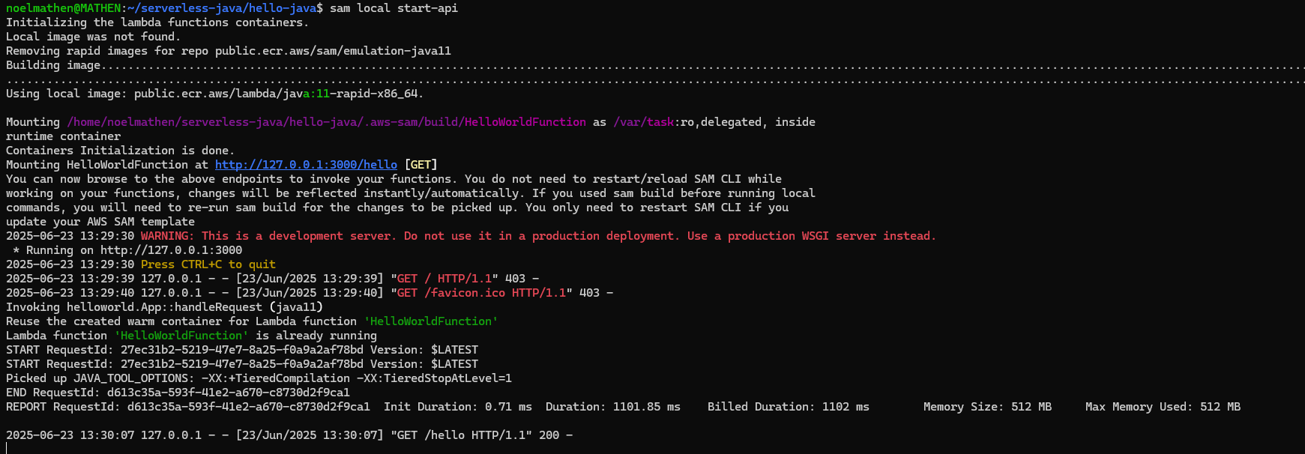



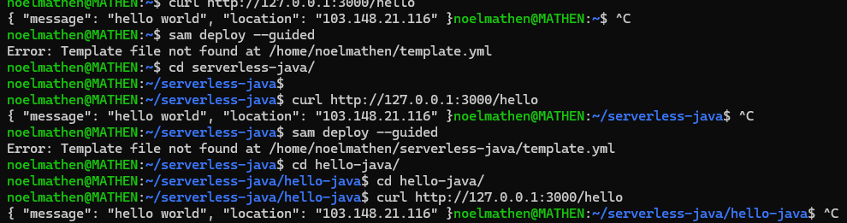

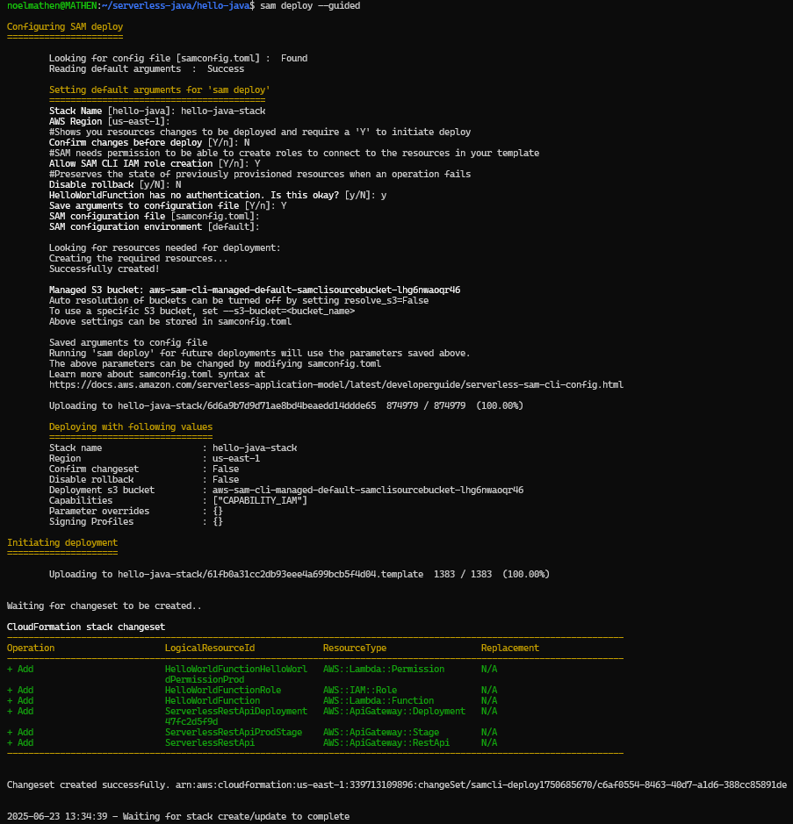

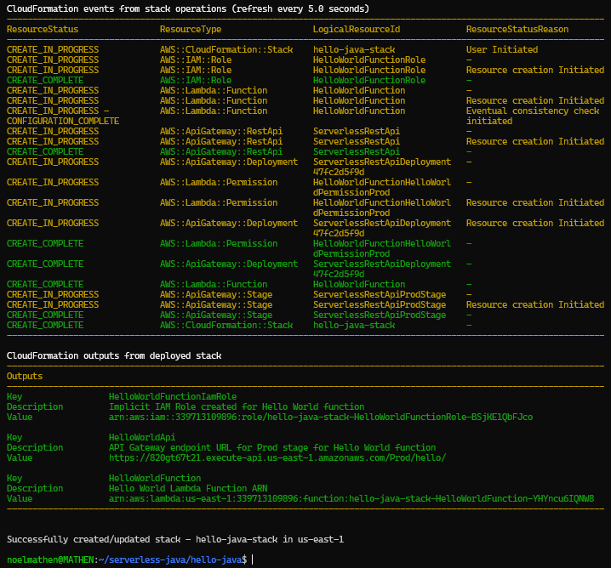

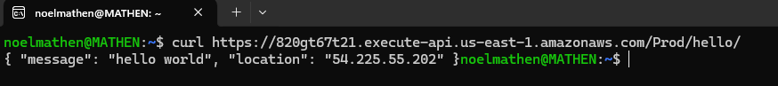

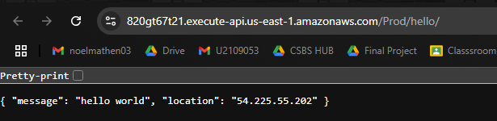

**3. “Hello World” Serverless in NodeJS**

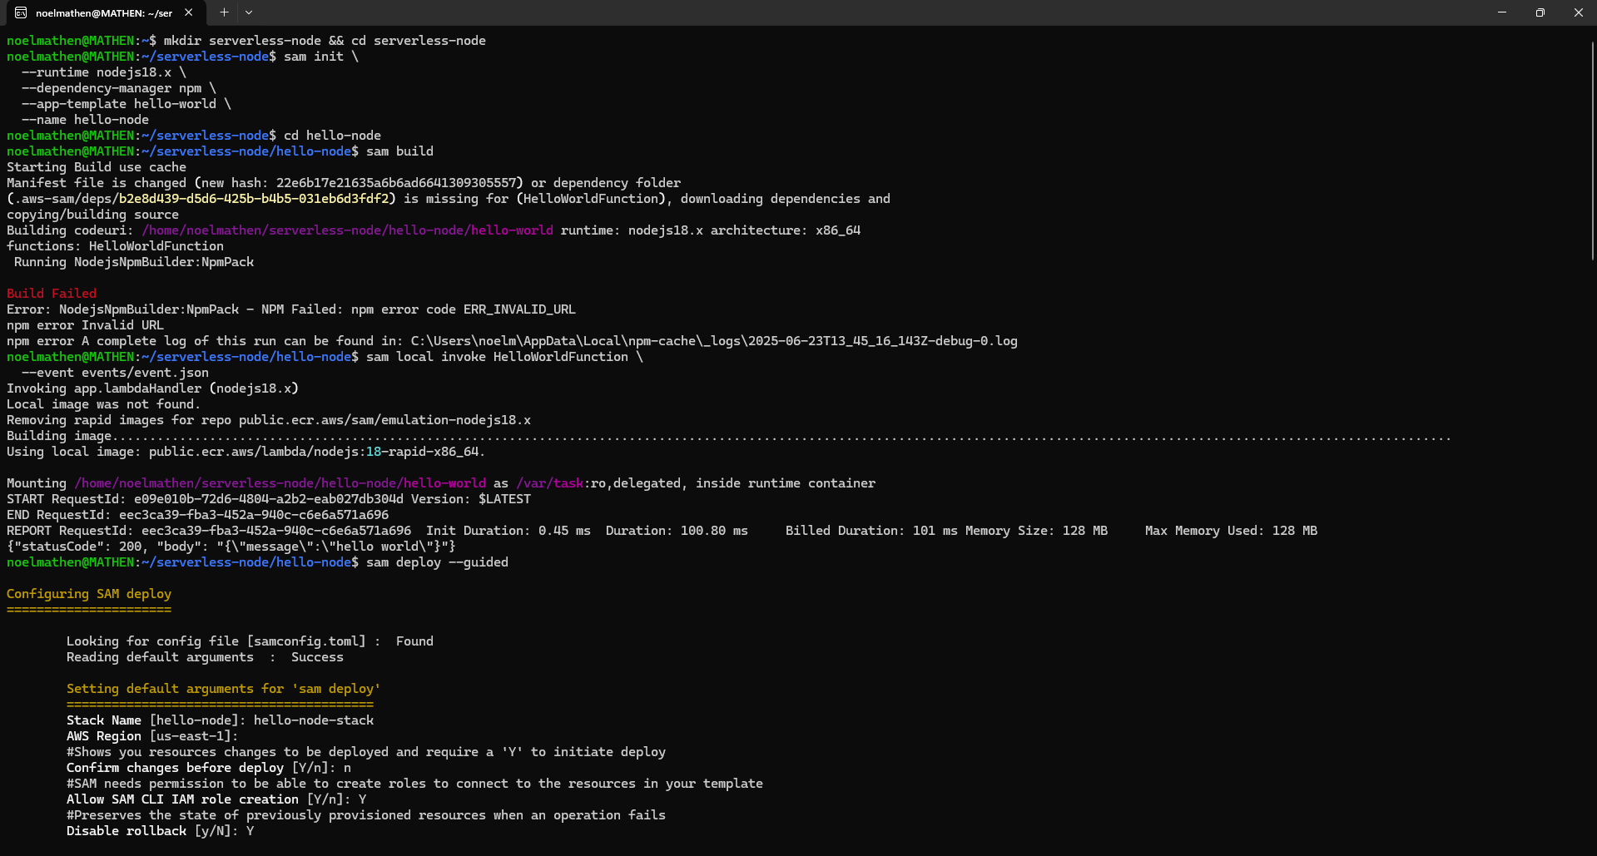

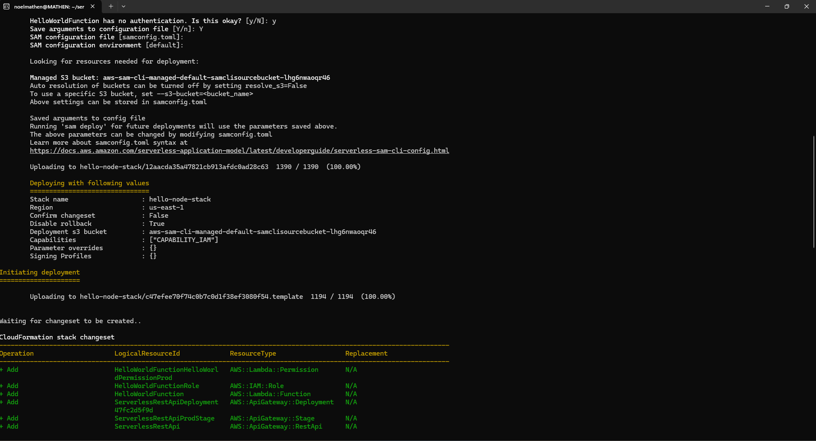

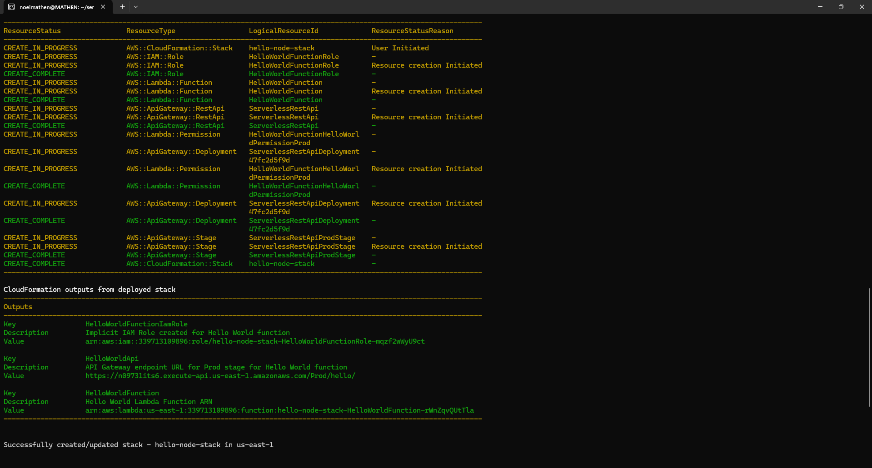

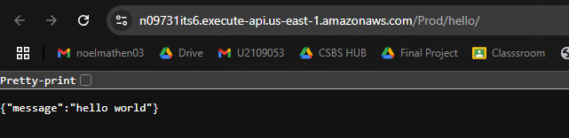

**4. Serverless via Docker Container Images**



